CAGRID IPHONE APP
Ad Hoc Build Deployment

Overview
This document describes deploying an ad hoc build of the caGrid iPhone App. This deployment configuration is only used for testing within CBIIT. In production mode, the app will be built for App Store distribution and submitted to Apple for review and publication.

Prerequisites
The following requirements must be met before attempting ad hoc deployment:
- Device is an iPhone, iPod Touch, or iPad
- Device is able to sync with an iTunes installation on a Mac or PC
- Device is running iOS version 3.1.3 or higher
- The UDID for the device is registered with the developers

Distribution Artifacts
The installation requires 2 artifacts: the Ad Hoc Distribution Certificate, and the application zip file.
Ad Hoc Distribution Certificate – The certificate contains the device UDIDs for which it is valid. It may only be used with the devices for which it was created. The certificate file is named *.mobileprovision.
Application Zip File – The application (or “app”) is a directory containing the application code and all of the application resources. It is usually distributed in ZIP or GZIP format.

Installation
- Start iTunes
- If you have previously installed the caGrid application on the device, remove it as follows:
  - Press and hold the application icon on the device. Tap the X when it appears to remove it from the device.
  - In iTunes navigate to Apps under the Library and locate the caGrid icon. Right-click and then click Delete.
- Connect the device to the Mac or PC
- If you have NOT installed the Ad Hoc certificate on the device before, drag the certificate file to the Library section of iTunes
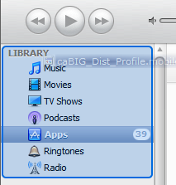
- Unzip the Application Zip File and drag the resulting directory into the Library section of iTunes
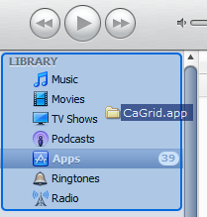
- Under the “Apps” tab, check the “Sync Apps” checkbox.
- Click on the device in iTunes and click “sync” to copy the application to the device
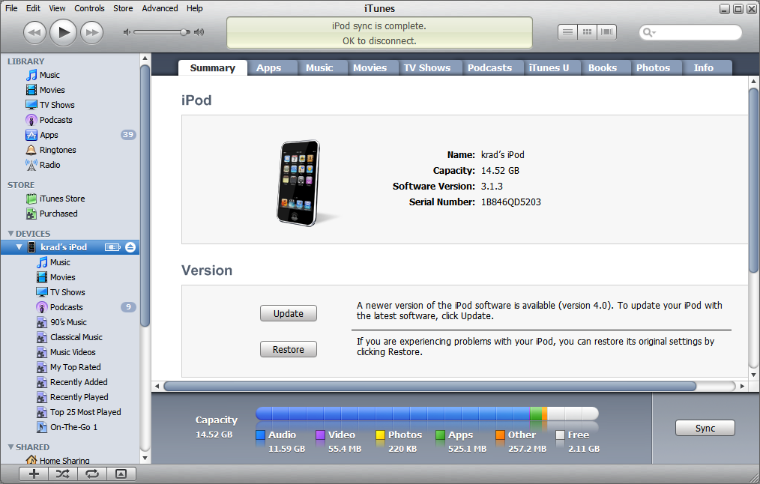

Running the Application
The caGrid iPhone App requires network connectivity and access to the GSS server. To access an internal (i.e. non-production) instance of GSS the iPhone must be configured with VPN into the CBIIT network. Once the GSS server is accessible from the device, the app may be launched as normal.

Appendix A
The UDID is a unique identifier for a device. To find the UDID connect the device to a Mac or PC and launch iTunes. Select the device from the Devices list and click the “Summary” tab. Click the word “serial number” to reveal the UDID.
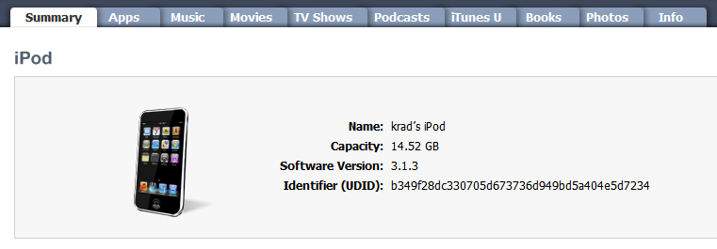

The version information is available on the device itself, under Settings->General->About->Version
See Appendix A for instructions on finding the UDID identifier for a device

